|  |  |  |  |  |  |  |
| --- | --- | --- | --- | --- | --- | --- |
| Description: Vertical full colour positive | Safety Bay Senior High School | | | | | |
| **CHEMISTRY UNIT 3 & 4** | | | | | | |
| **Test #5:** | | | | | | |
| **Chemical Synthesis** | | | | | | |
|  | | | | | | |
| **NAME:** | | |  | | | |
|  | | |  | | | |
| **Time allowed for this paper** | | | | | | |
| Reading time: | | 5 minutes | | | | |
| Working time: | | 50 minutes | | | | |
|  | | | | | | |
| **Structure of this paper:** | | | | | | |
| Section | | | Number of questions | Marks available | | Marks achieved |
| Section One: Multiple Choice | | | 7 | 7 | |  |
| Section Two: Short Answer | | | 7 | 47 | |  |
|  | | |  | | **Total** | ______ / 54 |

**Section One: Multiple Choice**

Answer all questions by circling the correct option. Only circle one option for each question.

**The next two questions refer to the following information:**

Ethanol (CH3CH2OH) can be produced from the reaction between ethene and water in the presence of a sulfuric acid catalyst.

C2H4(g) + H2O(g) ⇌ CH3CH2OH(g) ΔH = -46 kJ mol-1

1. When ethene and water reaction together to form an equilibrium mixture with ethanol, which one of the following best represents how the rates of forward and back reactions change over time?

|  |  |  |  |
| --- | --- | --- | --- |
| (a) | C2H4(g) + H2O(g) 🡪 CH3CH2OH(g)  CH3CH2OH(g) 🡪 C2H4(g) + H2O(g)  Rate  Time | (b) | C2H4(g) + H2O(g) 🡪 CH3CH2OH(g)  CH3CH2OH(g) 🡪 C2H4(g) + H2O(g)  Rate  Time |
| (c) | C2H4(g) + H2O(g) 🡪 CH3CH2OH(g)  CH3CH2OH(g) 🡪 C2H4(g) + H2O(g)  Rate  Time | (d) | C2H4(g) + H2O(g) 🡪 CH3CH2OH(g)  CH3CH2OH(g) 🡪 C2H4(g) + H2O(g)  Rate  Time |

1. At equilibrium at a particular temperature, 10% of the ethene is converted to ethanol. In order to increase the percentage yield of ethanol at equilibrium you should:
   1. lower the temperature and lower the pressure
   2. lower the temperature and raise the pressure
   3. raise the temperature and lower the pressure
   4. raise the temperature and raise the pressure
2. The following is the structural formula of a type of detergent: R-COO⁻ Na+

…where R represents a long chain alkyl group.

When this soap is placed into an aqueous solution containing grease one part of this compound is soluble in water and the other is soluble in grease. The hydrophobic part is the:

* 1. Na+
  2. The anion R-COO⁻
  3. The R-alkyl group
  4. The whole compound R-COO⁻ Na+

1. Which of the following substances will **not** act as a surfactant?
   1. Ammonium stearate (stearate ion = C17H35COO⁻)
   2. Calcium palmate (palmate ion = C15H31COO⁻)
   3. Hexadecylammonium sulfate (hexadecylammonium ion = C16H33NH3+)
   4. Sodium hexadecylsulfonate (hexadecylsulfonate ion = C16H33SO3⁻)
2. The following diagram represents part of a polymer chain in a plastic.

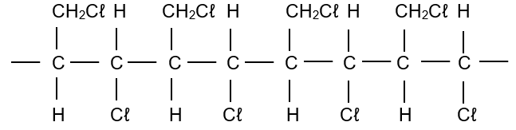

This polymer could be produced from:

1. *cis*-1,3-dichloropropene
2. *trans*-1,3-dichloropropene
3. dichloropropane
4. 1,2-dichloropropene
   1. I or II only
   2. II only
   3. III only
   4. I, II or IV only
5. The active component in superglue is:

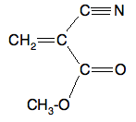

Which one of the following represents the polymer which is formed when the glue sets?

|  |  |
| --- | --- |
| (a)    n | (b)    n |
| (c)    n | (d)    n |

1. A piece of nylon string was placed in a beaker containing 10% sodium hydroxide solution. The solution was gently warmed and stirred for a period of six hours, after which the nylon string was no longer observed.

Which of the following reactions took place inside the beaker?

* 1. Hydrolysis
  2. Esterification
  3. Fermentation
  4. Condensation

**Section Two: Short Answer**

Write your answers in the spaces provided.

1. **(5 marks)**

Polyethylene terephthalate (PET) is commonly used in synthetic fibres.

The repeating unit of PET is shown below:

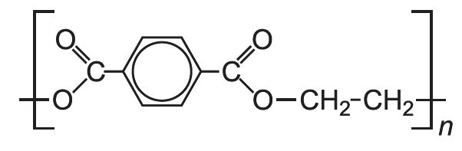

* 1. On the diagram above, **circle** and **name** the functional group(s) linking the monomers in PET.

(1 mark)

* 1. Show the structural formulas of the two monomers used to form PET. (2 marks)

|  |  |
| --- | --- |
| **Monomer #1** | **Monomer #2** |
|  |  |

* 1. Circle the response which best describes the classification of PET. (1 mark)

Addition polymer Condensation polymer Hydrolysis polymer Substitution polymer

* 1. Give the name or formula of another molecule produced when Monomer #1 and Monomer #2 react to form PET. (1 mark)

1. **(7 marks)**
   1. Draw the chemical structure of an anionic detergent derived from dodecylbenzene. (2 marks)

|  |
| --- |
|  |

The following diagram shows a representation of a detergent micelle.

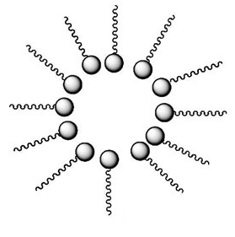

**Liquid 2**

**Liquid 1**

**Liquid 1**

**Liquid 1**

**Liquid 1**

* 1. Suggest a possibly identity for Liquids 1 and 2, and use this to account for the orientation of the detergent ions in the provided diagram. (5 marks)

1. **(8 marks)**
   1. Draw part of a chain of polyethene, showing exactly **three** repeating units. (2 marks)

|  |
| --- |
|  |

The properties of polyethene are dependent on the manufacturing conditions. Low density polyethene (LDPE) is manufactured using high temperatures and pressures, whereas high density polyethene (HDPE) is manufactured using low temperatures and pressures.

* 1. Other than density, list two differences in properties between LDPE and HDPE. (2 marks)

* 1. With the aid of a diagram, explain why the properties of LDPE and HDPE differ. (4 marks)

1. **(8 marks)**

Canola is Australia’s third-largest grown crop behind wheat and barley. Western Australia produces 40% of all canola nationwide. A majority of this canola is exported to Asia and Europe. The predominant use of canola has been for its edible oil, however it is becoming increasingly important as a source for biodiesel.

The following image shows the chemical structure of canola oil:

H

H

H

H

H

C

C

C

C

(CH2)7

(CH2)7

CH3

O

O

H

H

C

C

H

H

C

C

C

(CH2)7

(CH2)7

CH3

O

O

C

(CH2)7

O

O

H

H

C

C

C

H

H

H

H

C

C

(CH2)4

CH3

The production of biodiesel can be achieved through base-catalysed transesterification with methanol.

* 1. Draw the structure of **one** of the biodiesel molecules that could be produced from canola oil.

(2 marks)

|  |
| --- |
|  |

* 1. Name and draw the structure of the **non-biodiesel** byproduct of this reaction.. (2 marks)

|  |  |
| --- | --- |
| Structure: | Name: |

* 1. Lipase is an alternative catalyst to sodium hydroxide. Compare these catalysts by listing two advantages / disadvantages of each catalyst in the production of biodiesel. (4 marks)

Advantages of using lipase instead of sodium hydroxide:







Advantages of using sodium hydroxide instead of lipase:







1. **(6 marks)**

Esters are the basis of many naturally occurring odours and are therefore widely used in the creation of artificial flavours. Methyl butanoate is a component of the smell of pineapple. A manufacturer decides to test the use of some of this compound in an ice-cream mix by synthesising a sample using butan-1-ol and methanol as starting materials.

Using butan-1-ol and methanol as starting materials, draw a reaction sequence that could be used to prepare methyl butanoate. Each box should show the structural formula of an organic molecule, and each arrow should list any of other reactants or catalysts required for the reaction to proceed.

methyl butanoate

1. **(7 marks)**

Ethanol is produced through two main methods: the hydration of ethene and fermentation. The following table compares conditions used in each reaction.

|  |  |  |
| --- | --- | --- |
|  | **Hydration of ethene** | **Fermentation** |
| Temperature | 300 °C | 37 °C |
| Pressure | 60 – 70 atm | 1 atm. |
| Catalyst | Phosphoric acid | Zymase  (an enzyme found in yeast) |

* 1. Write an equation for the fermentation reaction that produces ethanol. (1 mark)

* 1. Explain, using collision theory, how the presence of a catalyst like phosphoric acid results in an increase in reaction rate. (3 marks)

* 1. Outline three reasons why fermentation could be considered as a ‘green alternative’ to the hydration of ethene. (3 marks)

Reason #1:

Reason #2:

Reason #3:

1. **(6 marks)**

Sodium carbonate can be produced by the Solvay process which involves the following four steps:

Step 1: NH3 + H2O + CO2 → NH4HCO3

Step 2: NH4HCO3 + NaCℓ → NH4Cℓ + NaHCO3

Step 3: 2 NaHCO3 → Na2CO3 + H2O + CO2

Step 4: Na2CO3 + 10 H2O → Na2CO3.10H2O

* 1. How many moles of Na2CO3.10H2O are produced for each 1 mol of NH3 consumed? (1 mark)

* 1. Calculate the mass of ammonia required to produce 2.0 tonnes of sodium carbonate-10-water. Assume the process is 90% efficient. *(1 tonne = 1x106 g)* (5 marks)